Ingredients
Name | Quantity (%)
Wheat Flour | 52.1
Water | 24.1
Vegetable Fat | 20
Baking powder | 2
Sugar | 1.2
Salt | 0.6
Colors (E Code or FD&C) | Quantity (%)
Flavours | Quantity (%)



TECHNICAL DATA SHEET
Product : Mini Square | SUPC : 5395975 | Date : 30 July 2026

Product Information
Reference Ravico | R8632S | 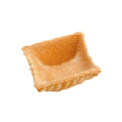
Dimension (L x l x h – Ø) (mm) | 35 x 35 x 15
Net weight (g) | ± 5
Bruto weight (g) | ± 5
Shelf Life | 10 months
Storage condition | Cool and Dry
Packaging
Label | Name | Sysco Supreme |  |  | Ref |  |  | 5395975 |  | Pcs / Box | 85
Label | Crt Net weight in kg (Lbs) | 1.6 (3.53 Lbs) |  |  |  |  |  |  |  | Box/ Crt | 4
Label | Crt Bruto weight in kg (Lbs) | 2.0 (4.41 Lbs) |  |  |  |  |  |  |  | Crt / Palet | 130
Label | Crt External dimension (mm) | 380 | L | 290 |  | w | 140 |  | h | Palet type | HT 100x120

All Information provided here above is strictly confidential between Ravico and it’s customer

Technical Data Sheet Mini Square (continued)

Chemical Analysis
Total Humidity | 3.5 %
Water Activity (Aw) | 0.32
Ashes | 3.86 %

Nutritional Facts
Total Protein |  | 8.3 | .g/100g
Carbohydrate | Total | 58.7 | .g/100g
Carbohydrate | Sugars | 5.5 | g/100g
Fat | Total | 23.5 | g/100g
Fat | Saturated | 10 | g/100g
Trans fatty acids |  | 0 | g/100g
Dietary Fibre |  | 2.1 | g/100g
Sodium |  | 1309 | mg/100g
Cholesterol |  | 0 | mg/100g
Calcium |  | 89 | mg/100g
Iron |  | 1 | mg/100g
Energetic Value |  | 480 | Kcal/100g
 |  | 2009 | KJ/100g

Microbiological Analysis |  |  | Allergy Information (EEC 2003/89)
Germ | Max CFU/g | Determination method | Milk products | - | Nuts | - | Vanillin | +
Coliforms | < 10 | Bacterio 140 At 37° | Lactose | - | Sesame | -
E. Coli | < 10 | Bacterio 011 | Egg product | + | Fish | -
Staphylococcus | < 100 | Bacterio 164 | Soya product | - | Crustacean | -
Moulds | < 10 | Bacterio 141 | Gluten | + | Sulphites | -
Yeasts | < 10 | Bacterio 143 | Wheat | +
 |  |  | Rye | +
 |  |  | Peanuts | -

Quality Assurance
Application of the rules of conduct in accordance with the system HACCP (93/43 EEC directive) and the legislation in force

Allergen information for labels
Contains Eggs.

Other Information
Is this product GMO free ? | Yes
Is this product Kosher ? | No

All Information provided here above is strictly confidential between Ravico and it’s customer
Filled in | Brussels | the | 30 July 2026 | by |  | signature

Technical Data Sheet Mini Square (continued)
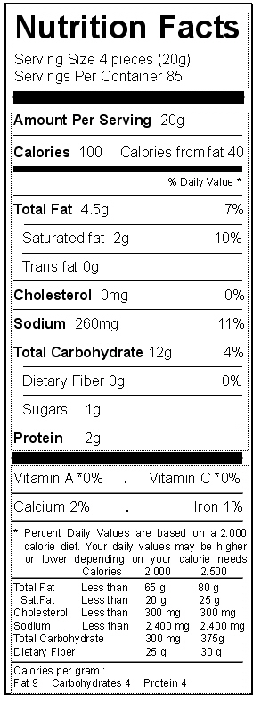
Last Updated: 30 July 2026

